Testing on Mobile App:

This is the user friendly and easy to use app.

You need to download the latest test versions from the hockey app links that developer sends.

After downloading,

When you open the app, left hand corner has the hamburger menu which has the same options as the landing page below,

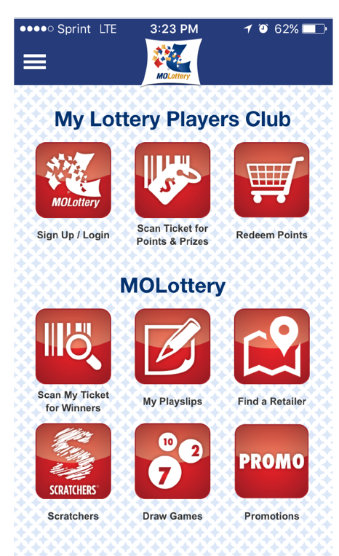

My lottery Players Club is owned by MOLO and SGI and is being tested by them.

We can smoke test to see all the items are performing good.

When you get any new version:

Test all the pages displayed in the image.

Scan my ticket for winners

My playslips: Create digital playslips for all the games

Find a retailer

Scratcher and promotions are iframe connected to MOLO’s website

Draw games: Check cosmetic stuff and jackpot values,prizes paid page

Keno drawings